Part of: Introduction to Databases & SQL
- To design and create a relational database schema for an E-Commerce system using SQL.The schema is designed to store users, products, orders, order items, and payments with proper relationships.

Database Name:- ecommerce_db

Table Structure & SQL Queries

Users Table:-Stores customer information.
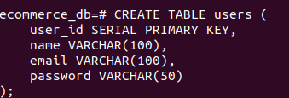

Products Table:-Stores product details available for sale.
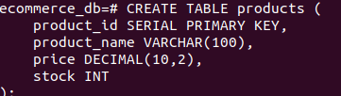

Orders Table:-Stores order information placed by users.
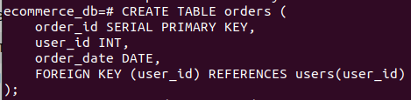

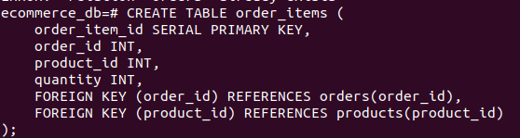
Order_Items Table:-Stores product details for each order.

Payments Table:-Stores payment details for orders.
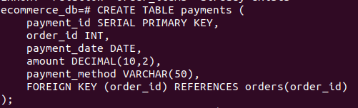

Table Relationships
Parent Table | Child Table | Relationship Type
users | orders | One-to-Many
orders | order_items | One-to-Many
products | order_items | One-to-Many
orders | payments | One-to-One
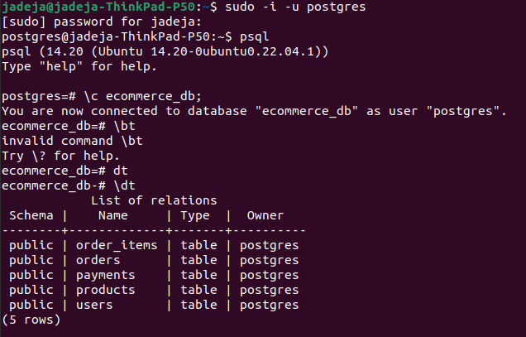

Conclusion
The E-Commerce database schema is successfully designed using SQL.
It provides a structured, scalable, and secure foundation for managing online shopping data.

